Entry fields indicated with an asterisk are required.
Changing email addresses in Blackboard is an easy two step process. Please note that the change function requires you to enter a CUNY email address.

- Access Blackboard and locate the Tools module on your Home tab. This should appear at the top of the left-column. Click the link labeled Update Email.

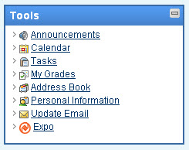
Click
Update Email

- On the Update Email Address screen, enter your John Jay email address twice, and hit Submit at the bottom.

