

Logging into Blackboard 6

Welcome to Blackboard at John Jay College. This handout is for students taking asynchronous classes (a class taught totally online), hybrid classes or on-campus classes that use Blackboard as a supplement. You can access Blackboard and your course from home, school or work – from anywhere you can get access to the Internet. However, some places of work have filters that may prevent you from logging into Blackboard.

- To access your course on Blackboard, log onto the Internet and go to: http://www.cuny.edu. This action will put you at the CUNY Portal. In order to access your classes you must be registered for the "Portal".

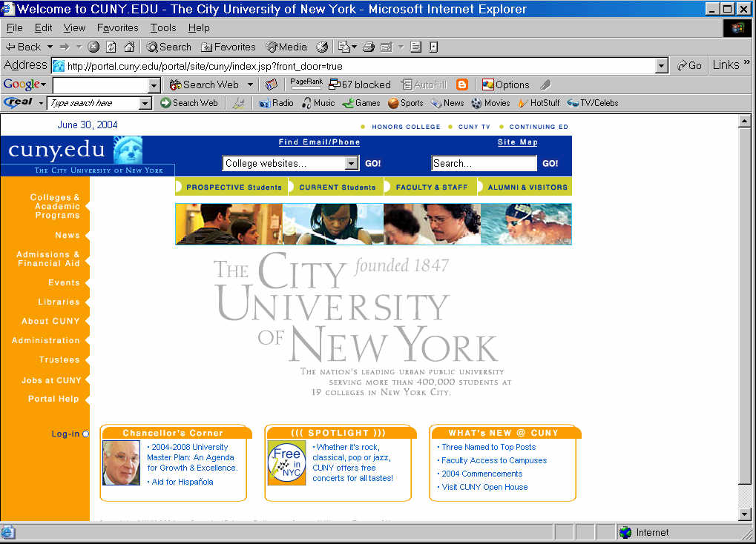
Click on "Log in"

- Above is the CUNY Portal page. The next click will bring you to the "log in" page. If you are already registered, complete the required information. If you are not registered for the Portal, click on "Register Now" and follow the instructions.

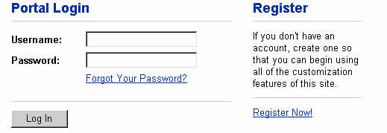
- Once you log in successfully, you will be taken to the “My Page” screen. Here you will see "Blackboard" underlined. Click on it.

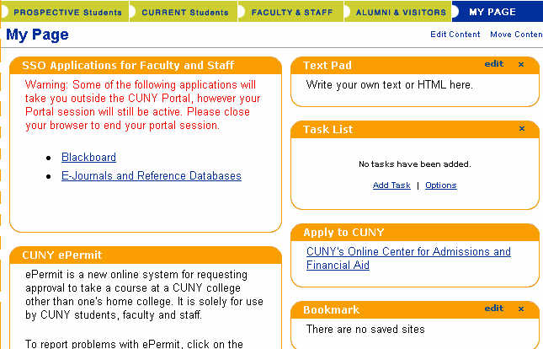
Blackboard

- You will see the following screen that identifies you either as a guest or a student. Click on student.

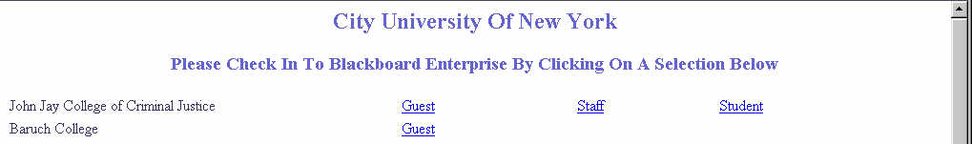
Student

- The next window shows your courses identified in the upper right side of the window.

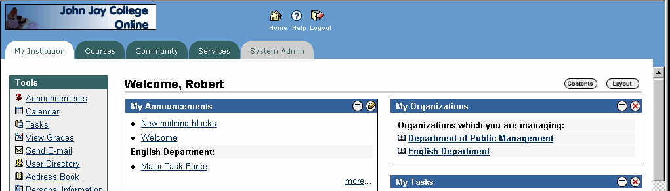

- If you have any problem with username and password in accessing Blackboard, please call the John Jay College Help Desk at 212-237-8200 from Monday through Friday from 9:00 a.m. - 6:00 p.m. or send an e-mail to Professor Robert Hong at rhong@jjay.cuny.edu. You may also stop by the office in 3410 North Hall anytime Monday through Friday from 9:00 a.m. – 5:00 p.m. If the Portal is down use the backdoor to access Blackboard. The address is: https://blackboard-doorway.cuny.edu

